Todo temática morado y blanco, como el logo en sí.
1ª Diapositiva
En esta diapositiva que aparezca nuestro logo final con únicamente el eslogan: “Decode Hits, Discover Souns”. A mí me mola la idea de poner 5 segundos el estribillo de la canción que hicimos y decir:
"Sounds familiar, right? But you've never heard that song before. That's because it was created by artificial intelligence — using the most common lyrical patterns found in chart-topping hits."
"So that brings us to the big question..."
"What if we could predict whether a song will be a hit — before it’s even released?
Welcome to 'Hit or Flop'—where we decode hits and discover sounds.""
2ª Diapositiva (Index)
En esta diapositiva aparecerá el Índice:
Index
- Project Goals and Values
- Data Collection
- Data Processing and Preparation
- Association Rule Analysis
- Prediction Model
- Lyrics Analysis
- Key Findings
- Future Directions
La persona que lo presente dirá:

"This is the outline of our presentation. We’ll follow the same order we used during the project: starting with our goals, then the data collection, how we built and trained the models, and finally, how we see this evolving in the future."

3ª Diapositiva (Project Goals and Values)
En esta diapositiva poner lo siguiente o parecido:
Goals
- Help artists & labels make better decisions
- Support creative and strategic choices
- Identify patterns in music & lyrics
- Predict a song's success and popularity
Models Used
- Association Rules
- Hit or Flop Classifier
- Popularity Regression Model
- Lyrics Analysis
Core Values
- Data-driven creativity
- Transparency & explainability
- Empowerment through insight
- Innovation in music decision-making
Texto hablado:
"The main goal of Hit or Flop is to give artists and music labels data-driven tools to support smarter decisions. Whether it’s about choosing the right musical style, knowing what lyrics are more likely to connect with audiences, or deciding if it’s worth going on tour — or even releasing a new version of an old album — we want to provide insights that matter."
"To do this, we built several models: one to find common patterns using association rules, a classifier to predict if a song will be a hit or a flop, a regression model to estimate how popular it could be, and a lyrics analysis to better understand what language resonates with success."
"Our values reflect what we believe this project stands for: combining data with creativity, making our methods transparent and explainable, and ultimately empowering artists through insight and innovation."
4ª Diapositiva (Data Collection)
Diapositiva:
  - Initial dataset: audio features, artist, year, popularity
  - Missing metadata: genres, lyrics
  - Supplemented with:
    - Spotify API – audio features & artist genres
    - Kaggle – base datasets on song popularity
    - Last.fm API – song-level genre tagging
    - AZLyrics – lyrics scraping
  - All sources cleaned & integrated for análisis
Texto hablado:
"We started with an initial dataset that included songs along with features like speechiness, loudness, instrumentalness, the artist, year of release, and their 2021 popularity score.
However, we quickly realized that important metadata was missing — especially genres and lyrics, which are considered highly relevant according to the literature we reviewed.
To enrich our dataset, we integrated information from multiple sources. We used the Spotify API to gather audio features and artist genres, Kaggle for base popularity datasets, the Last.fm API for more detailed genre tagging at the song level, and AZLyrics scraping to collect lyrics.
All of this data was cleaned and merged to support a deeper, more accurate analysis."
5ª Diapositiva (Data Processing and Preparation)
Este apartado lo dividiría en dos diapos o como veas, es bastante largo.
Presentación:
Combined data from 2021 & 2024
Added 2025 popularity for updated insight
Filled missing 2024 metadata via Spotify API
Averaged popularity if songs appeared in both years
Removed duplicates & cleaned structure
Genres from Last.fm (song-level) & Spotify (artist-level)
“Unknown” tag used for missing genres (hasta aquí una diapo)
Cleaned column names & merged rows by track ID
Removed podcasts, audiobooks, & outliers
Standardized genre labels (e.g., "jpop" → "j-pop")
Discretized popularity into 4 classes:
- FLOP (≤25), MID (26–50), MID-HIT (51–80), HIT (>80)
Discretized all audio features for rule análisis

"We began by integrating datasets from 2021 and 2024, enriching them with updated popularity data from 2025. To align both tables, we ensured they had the same variables — including song titles and artists, which were missing in the 2024 dataset.
We used the Spotify API to retrieve this missing metadata and added a new popularity score for 2025. If a song appeared in both 2021 and 2024, we averaged the values to simplify analysis.
Duplicate song IDs were removed, and genre information was pulled from both Last.fm — which offers song-level tagging — and Spotify. When no genre could be found, we labeled it as “Unknown”." (hasta aquí correspondería a la primera diapo)
Once all songs had consistent structure, we cleaned the dataset. We corrected column names, merged duplicate tracks across years, and filtered out irrelevant entries like podcasts or audiobooks.
We also standardized genre names to avoid label duplication — for instance, turning 'jpop' into 'j-pop'.
To prepare for association rule mining, we discretized popularity into four classes: FLOP, MID, MID-HIT, and HIT. We did the same with audio features, creating thresholds for each one based on their distribution."
Diapositiva: Association Rule Analysis
1ª Diapo
- 4 types of rules generated (one per popularity class)
- Focus on most confident rules for HIT and FLOP
- Goal: Help artists spot good combinations — or avoid bad ones
- Visual comparison of top 2 rules for each category
Texto:
"Although we generated association rules for all four popularity categories, we’ll focus on the two extremes: HIT and FLOP.
The idea is to identify what combinations of musical features tend to appear in songs that are either very successful or completely overlooked.
In the next slides, we’ll look at the top two rules for each case, based on their confidence scores."
2ª Diapo (para las reglas HIT)
  - Metrics
  - Confidence: 0.62%
  - Support: 0.12%
  - Common traits:
  - High Danceability & Energy
  - Low Speechiness, Instrumentalness, Liveness
  - Mid Duration
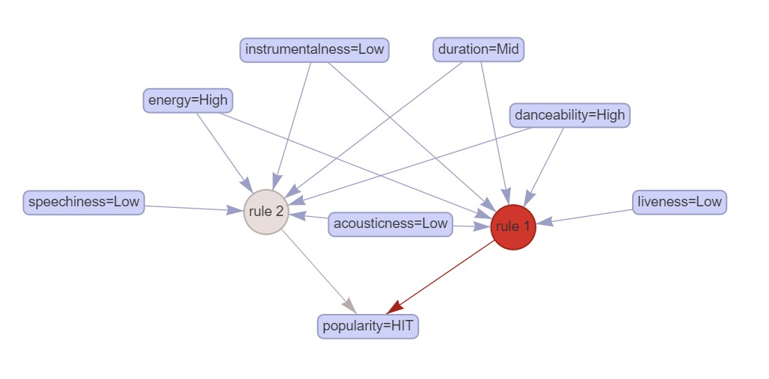
Texto:
"With the HIT rules, we can see a very specific but rare pattern. Both rules point to songs that are energetic, danceable, and have low speechiness, low instrumentalness, and low liveness.
They also tend to have mid-length durations and low acousticness, which aligns with many popular music trends.
However, even though these features sound like a good formula for success, the support and confidence remain very low — just around 0.12% and 0.62% respectively.
This tells us that hits may follow more complex or varied paths, and simple combinations are not consistently predictive in this case."
3ªDiapo (para las reglas FLOP)
Metrics
- Confidence: 99.7%
- Support: 1.02%
Common traits:
- Low Energy, Acousticness, Loudness
- High Speechiness
- Short Duration
In contrast with HIT rules:
- HITs had High Energy and Low Speechiness
- FLOPs show the opposite pattern
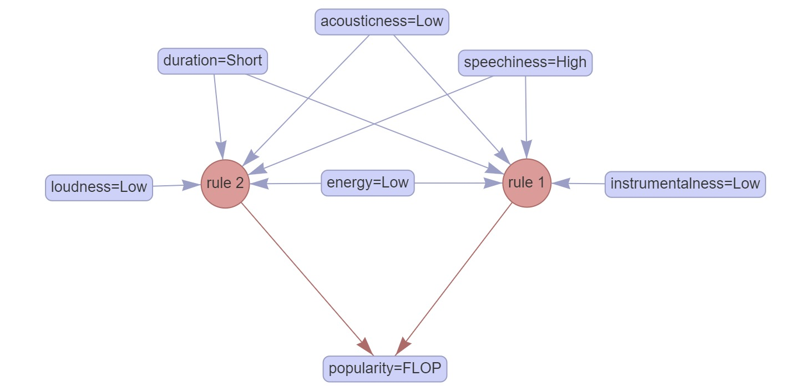

Texto:

"In contrast, the rules associated with FLOP-level popularity are far stronger.
Both top rules show a confidence of nearly 99.7%, and a support of over 1% — making them much more meaningful.
While HIT rules featured high energy and low speechiness, here we find the exact opposite: low energy, high speechiness, and shorter durations.
These are clear red flags: artists and producers might want to avoid this mix of features if their goal is to reach a wider audience."
Prediction Model
- Data Preparation and Zero-Inflated Split
We began with a single master dataset of songs, extracting a consistent feature set by dropping identifiers, string-encoded duplicates, and categorical “bin” columns (e.g. *_cat), leaving only the raw audio, temporal, and metadata features in X and the continuous target new_popularity_2025 in y. To build our two-part (“zero-inflated”) pipeline, we then split these records into a binary classification task—predicting whether new_popularity_2025 > 0—using all rows, and a regression task—predicting the exact popularity value—using only the non-zero subset.
- Common Preprocessing Pipeline
For both stages, we applied identical preprocessing: we automatically detected numeric columns (int64, float64) and standardized them via StandardScaler, and we one-hot-encoded all remaining object-dtype categorical features (e.g. season, genre_final) with OneHotEncoder(handle_unknown="ignore"). We combined these transforms into a single ColumnTransformer and wrapped it plus the estimator in an sklearn Pipeline, guaranteeing that every candidate model saw the same inputs.
- Stage 1: Binary Classification GridSearch
In the first stage, the binary classifier, we defined separate hyperparameter grids for each of four candidate algorithms—Random Forest, XGBoost, Gradient Boosting, and Logistic Regression—each wrapped as the clf step in our pipeline. For example, the Random Forest grid tuned n_estimators, max_depth, min_samples_split/leaf, and max_features='sqrt'. We then ran a separate GridSearchCV for each estimator (3-fold CV, scoring=f1_macro) and recorded the best estimator for each family.
- Stage 1: Classification Evaluation
Once each model’s best hyperparameters were found, we evaluated them on the held-out test set, computing Accuracy, F1-Macro, Precision-Macro, Recall-Macro, and ROC AUC. We summarized these metrics in a comparison table, then selected Random Forest as our binary classifier—the highest F1-Macro (0.6755) and Recall-Macro (0.6896) made it most reliable for the imbalanced zero/non-zero split.
- Stage 2: Regression GridSearch
In the second stage, the positive-only regressor, we again defined separate grids for four candidate regressors—Random Forest Regressor, XGBoost Regressor, Gradient Boosting Regressor, and K-NN Regressor—tuning each model’s key hyperparameters (e.g. n_estimators, learning_rate, max_depth, etc.). We ran independent GridSearchCV jobs (3-fold CV) for each regressor, scoring on a multi-metric dictionary (neg_root_mean_squared_error, neg_mean_absolute_error, r2), and refitted to the parameter set that minimized RMSE.
- Stage 2: Regression Evaluation
After hyperparameter search, we compared regressors on the same test subset (only non-zero songs) by computing RMSE, MAE, and R². XGBoost emerged with the best balance of sub-second retraining time (<1 s) and top accuracy (RMSE=14.7706, MAE=11.5362, R²=0.3089), making it our final continuous-popularity model.
- Integration into Two-Stage Pipeline
Having chosen Random Forest for the first stage and XGBoost for the second, we combined them into a sequential workflow:
Binary RF predicts zero vs. non-zero popularity.
Regression XGB takes only the non-zero subset and predicts the specific popularity score.
This “hurdle” architecture respects the zero-inflated nature of the data and ensures each stage is optimized independently for its distinct objective.
We retained consistent preprocessing across both stages for maintainability. Although Random Forest remains a “black-box” ensemble, its decisions for individual tracks can be interrogated directly—one can trace which splits or combinations of features drove a song into the zero-popularity class and even reconstruct the decision paths as human-readable rules. XGBoost, by contrast, integrates seamlessly with SHAP for efficient, additive explanations of global and local feature impacts on the continuous‐popularity predictions. This combination—rule‐traceable classification and SHAP‐backed regression—ensures both stages of our zero-inflated pipeline remain auditable, interpretable, and production-ready.
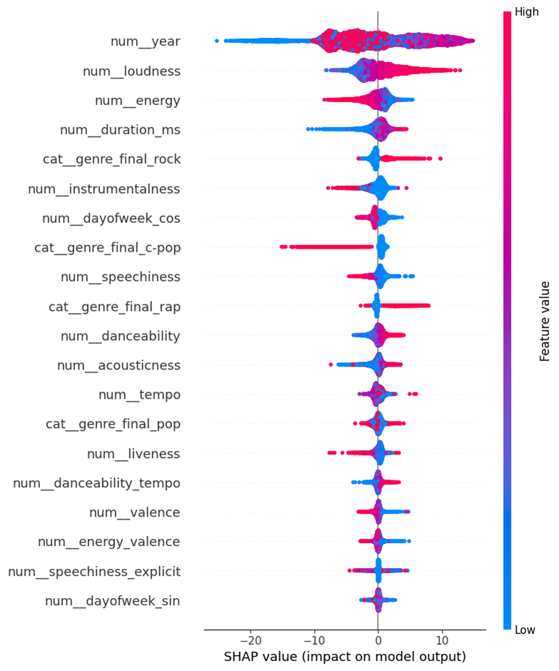
"By applying SHAP to the XGBoost model, we gained deeper insight into which features most influenced the popularity predictions.
Release year emerged as the most impactful variable, but with a non-linear pattern: songs from mid-range years provided a stronger boost than very recent or older tracks.
Loudness had a consistently positive effect, while surprisingly, high energy values sometimes reduced predicted popularity—suggesting that overly intense songs may limit broader appeal.
Genre also played a significant role: Rock and Rap tracks generally improved scores, while genres like C-Pop had a negative influence.
These SHAP results confirmed that a focused set of audio and temporal features drives much of the model’s predictive performance."

Lyric Analysis
Diapositiva 1: Lyrics Analysis – Overview & Goals
Contenido de la diapositiva:
- Título: Lyrics Analysis - How words and emotions shape song success
- Texto:
  - Podemos poner un workflow tal que: "Original lyrics → Cleaning & Contractions Expansion → Analysis"
  - Scraped lyrics from AZLyrics (2018–2025)
  - Preprocessed & cleaned + Translation to english
  - Sentiment & topic modeling applied to understand popularity
  - Main goal: Identify patterns linked to popularity
Guion hablado:

"In this section, we are going to analyze song lyrics to understand which words, emotions, and themes appear more frequently in hits versus flops. We collected lyrics from AZLyrics for songs among 2018 to 2025. Since many tracks were in different languages, we translated them into English to ensure consistency. Then, we cleaned and normalized the text to prepare it for deeper linguistic and sentiment analysis."

Diapositiva 2: Preprocessing & Sentiment Detection
Contenido de la diapositiva:
- Tools: langdetect, deep_translator, nltk
- Sentiment labels: Positive / Neutral / Negative
- Example table snippet (mini version of the image with cleaned_text and polarity à está en el report)
Guion hablado:

"Before analyzing the lyrics, and such as I said before, we format the lyrics by expanding contractions and cleaning the text to make it easier to process linguistically. This helped to improve part-of-speech tagging and made sentiment detection more reliable. We then used nltk to classify each song as positive, neutral, or negative — revealing the emotional tone behind the lyrics."

Diapositiva 3: Topic Modeling (LDA)
Contenido de la diapositiva:
- Título: Topic Discovery with LDA
- Texto:
  - Latent Dirichlet Allocation used
  - Chosen for interpretability and efficiency
  - Reveals common themes across lyrics
- Graphic: Bar chart or distribution image of 5–6 discovered topics
Guion hablado:

"We also applied LDA to detect recurring themes across all lyrics. This allowed us to map songs to dominant themes and see how topics correlate with song popularity. It is worth noting that there are other methods, such as BERT, that can return better results, but given the magnitude of our problem and the resources required by these other methods, we have decided to stick with the results provided by LDA due to the balance it offers between performance and interpretability."

Diapositiva 4: Sentiment & Topic vs. Popularity
Contenido de la diapositiva:
- Dos gráficos de barras de popularidad (están en el report) de:
  - Sentiment distribution
  - Topic distribution
Guion hablado:

"To continue, we compare sentiment and topic distributions between popular and unpopular songs. When we examine the emotional tone of lyrics, we can see that popular songs tend to exhibit a slightly higher proportion of positive sentiment, while unpopular tracks show a modest increase in negative ones. However, the overall sentiment structure remains balanced in both cases, with neutral content being the less common.
On the thematic side, the distribution of topics remains remarkably similar between hits and flops. Each topic appears with roughly the same frequency, regardless of a song's success level.
Sentiment and topic distributions are nearly identical between popular and unpopular songs. This suggests that neither emotional tone nor lyrical theme alone predicts success, so other factors likely play a more decisive role.”

Diapositiva 5: Word Clouds – Most Frequent Terms
Contenido de la diapositiva:
- Two word clouds: popular songs vs. unpopular songs
Guion hablado:

"Finally, we decide to visualize the lyrical style of each group with wordclouds. In hit songs, we see casual and emotionally terms as yeah, baby, love, and heart, which help to create an expressive tone. On the other side, unpopular songs share some of these terms, but their vocabulary is more diffuse, possibly reflecting weaker main thematic."

(No sé si esto añadirlo aquí o comentarlo más general para el punto de conclusiones)
(Opcional) Diapositiva 6: Conclusions from Lyrics Analysis
Contenido visual sugerido:
- Texto:
  - Conclusiones (en grande)
Guion hablado:

"To sum up, the analyses show that popular and unpopular songs share very similar structures, both in emotional tone and thematic content. This suggests that success is not necessarily linked to what is sung, but perhaps to other aspects such as expressiveness, clarity, and relatable language.

Key Findings (conclusions)
  - No single feature guarantees success — patterns are complex
  - Prediction improves when tasks are split and models are interpretable
  - Audio traits and release timing matter more than lyrics
  - Lyrics show small differences, but style may influence appeal
  - Combined models offer practical guidance for artists and labels

"To summarize our findings: success in music isn’t tied to one specific pattern or feature — it's the result of complex combinations.
Our prediction performance improved significantly by separating tasks and using interpretable models, especially through SHAP.
We found that audio features and release timing had greater impact than lyrical content, which showed only subtle differences between hits and flops.
However, popular songs did lean slightly toward more expressive and emotionally engaging language.
Altogether, combining these analytical approaches allows us to offer meaningful and actionable insights to support artists and music professionals."
Future Directions
Diapositiva:
- Launch artist-facing app (mockup ready)
- Analyze popularity across seasons
- Partner with platforms (e.g., Apple Music, YouTube Music)
- Integrate social media trends (TikTok, Instagram)
- Long-term: AI-generated music based on predictive features
Texto:

"Looking ahead, our first step is to develop a fully functional app for artists and labels — a platform where they can test their tracks, get predictions, and receive tailored suggestions. We already have a working mockup, which brings us closer to turning this into a real, usable product.”
We aim to expose the models via a server API so clients stay lean and fast. Users could send song features—or even raw audio for server-side extraction—and receive: (1) a binary “will it be popular?” prediction, and (2) a continuous popularity score when positive. Centralizing inference ensures the full, high-precision model stays intact, avoids shipping heavy ML libraries to devices, and simplifies client apps. It also lets us update models and feature extractors instantly, monitor performance, enforce data validation and rate limits, and scale as needed. This setup delivers accurate, low-latency forecasts without compromising user experience or prediction fidelity.
Another key direction is to refine our popularity metrics by tracking them over time — not just once per year. This could help identify seasonal trends, so artists know when their song has the best chance to resonate, depending on its style and mood.
Beyond that, we aim to collaborate with other platforms like Apple Music or YouTube Music to compare how popularity is defined, and to integrate social media trend data from TikTok or Instagram. And finally, in the long term, our ambition is to build generative models capable of composing entire songs — not just lyrics, but full tracks shaped by the features we've identified as most impactful.
The AI-generated song you heard at the beginning? That was just a starting point — a proof of concept.
What comes next is music created with purpose, with insight, and maybe, just maybe... with the formula for the next big hit."

Popularity prediction
Phase 1, binary classification:
Metrics

 | MODEL | ACCURACY | F1 MACRO | PRECISION MACRO | RECALL MACRO | ROC AUC
0 | rf | 0.690341 | 0.675479 | 0.674303 | 0.689567 | 0.761970
1 | xgb | 0.717842 | 0.655327 | 0.691012 | 0.648198 | 0.766888
2 | gbc | 0.718191 | 0.649313 | 0.694743 | 0.642726 | 0.762162
3 | lr | 0.684263 | 0.531557 | 0.685817 | 0.562024 | 0.673535

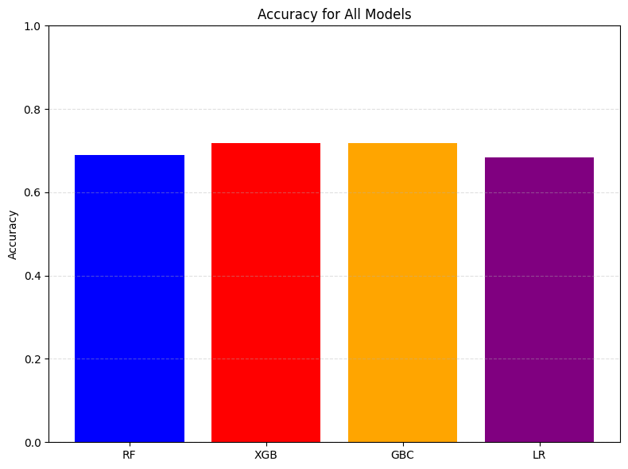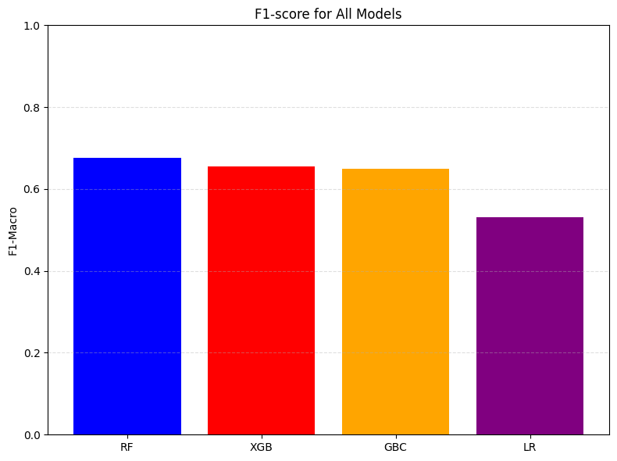
Prediction times
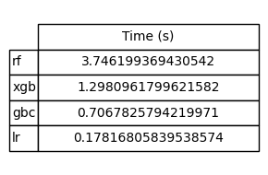
ROC curves for evaluated models
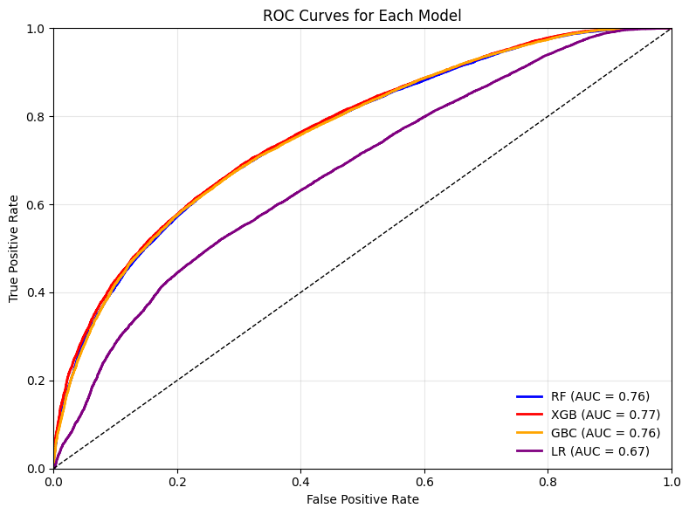
Phase 2, regression

Metrics

 | MODEL | RMSE | MAE | R2
0 | rf | 14.871112 | 11.72458 | 0.299426
1 | xgb | 14.770578 | 11.53620 | 0.308866
2 | gbm | 14.945273 | 11.73973 | 0.292421
3 | knn | 16.497899 | 13.00900 | 0.137767

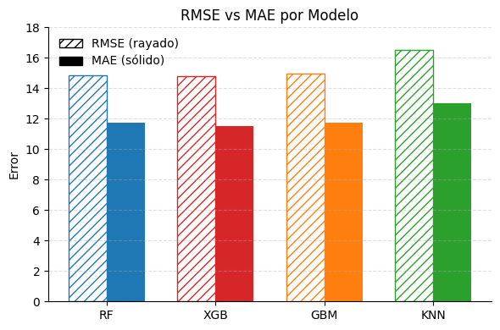
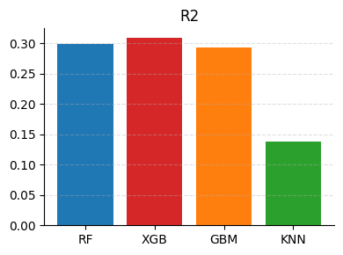
Prediction times
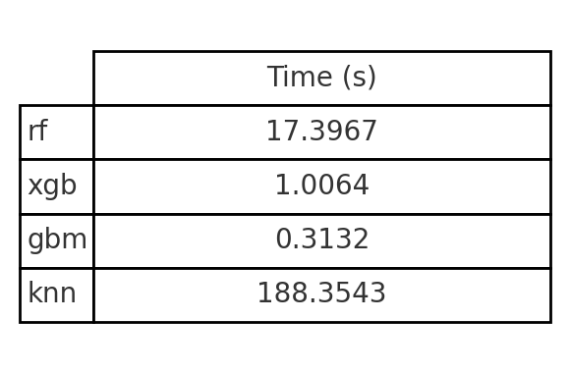
PREDICTION MODEL

Intro:

The final objective is to determine whether a track will achieve any measurable popularity and, if so, estimate its score.

The main purpose of this tool is to provide artists with pre-release feedback and empower creators with instant guidance, saving time and production costs.

However, the main challenges were that the temporal coverage is limited (2021 and 2024), spotify no longer provides access to audio features – so users may have to estimate them by themselves -, and a highly skewed target variable, because there are many zero popularity tracks.

Given all this limitations, we changed our approach to a 2 phase modelling, firstly we created a genre predictor to enhance data quality, so that we could impute the “unknown” values in the genre column, and later with this data, we aim to create a zero-inflated model.

---------

Zero inflated model:

Why a zero inflated model? Because it provides a robust solution for handling excess zeroes and letting us predict popularities correctly

In this plot, you can see our main problem: the high frequency of 0 popularities. This causes a bias where the model will always tend to predict 0.

And this second plot shows the same but without these problematic 0 popularities.we see A much more normal distribution.

Taking into account this, the idea is to transform the highly skewed distribution of popularity to a normal distribution by separating zero and non-zero.

After that binary model is stablished, the main task of quantifying popularity will be delegated to a regression model, in case it is non-zero class.

As we see, by having this approach we can handle excess zeroes without biasing estimations, and we can generate different interpretability reports for each model. However, the complexity of this approach is higher than just having a conventional all in one model. We needed to make sure that we have enough examples in both groups for the binary classification, and later we needed to ensure that sequential predictions do not take too long to compute.

--------

Data preparation:

Firstly, we began by imputing missing data for “unknown” genres, we ended up using a random forest classifier, we tested different number of genres predictions, and we ended up selecting the top 15 most popular genres. This model had a macro f1 score of 52.2% and weighted precision of 62.77%, which turned out to be one of the highest we could generate given the dataset. At the same time, we applied feature engineering to create newly combined features, and also we dropped highly correlated columns. With this approach, we could then divide the dataset into two versions, one for predicting “zero” or “non-zero” by converting to binary the target variable, and a secondary subset for regression only with >0 popularity tracks.

In both cases we applied identical preprocessing, standarising via StandardScaler and appliying one-hot enconding to categorical features. With that process, we tested several models for each task by using a sklearn pipeline with GridSearch for obtaining the best hyperparameters.

--------

Model 1:

Now we will discuss the binary classifier, the tested models with GridSearch were Random Forest, XGBoost, Gradient Boosting, and Logistic Regression. We then ran a separate GridSearchCV for each estimator using a 3-fold Cross Validation, and using F1-Macro as main scoring metric, given it was an unbalanced classification task. We also gathered additional metrics for each model.

We summarized these metrics in a comparison table, then selected Random Forest as our binary classifier—the highest F1-Macro (0.6755) and Recall-Macro (0.6896) made it most reliable for the imbalanced zero/non-zero split.

----------

Model 2:

In the second stage, the positive-only regressor, we again defined separate grids for our candidate regressors: Random Forest Regressor, XGBoost Regressor, Gradient Boosting Regressor, and K-NN Regressor. Again, we ran independent GridSearchCV jobs (3-fold CV) for each regressor, scoring on a multi-metric dictionary (neg_root_mean_squared_error, neg_mean_absolute_error, r-squared (R2)), and refitted to the parameter set that minimized RMSE.

After hyperparameter search, we compared regressors on the same test subset (only non-zero songs). XGBoost emerged with the best balance of retraining time (<1 s) and top accuracy (RMSE=14.7706, MAE=11.5362, R²=0.3089), making it our final continuous-popularity model.

-------

Conclusions:

So, in the end we have a 2-phase model that uses a Binary RF predicts zero vs. non-zero popularity and a XGBoost regressor that takes only the non-zero subset and predicts the specific popularity score.

This architecture respects the zero-inflated nature of the data and ensures each stage is optimized independently for its tasks.

Although Random Forest remains a “black-box” ensemble, its decisions for individual tracks can be interrogated directly—one can trace which splits or combinations of features drove a song into the zero-popularity class and even reconstruct the decision paths as human-readable rules.

XGBoost, by contrast, integrates seamlessly with SHAP for efficient explanations of global and local feature impacts on the continuous‐popularity predictions.

This combination—rule‐traceable classification and SHAP‐backed regression—ensures both stages of our zero-inflated pipeline remain auditable, interpretable, and production-ready.

The SHAP results confirmed that the models predictive performance is focused on a set of audio and temporal features. We will discuss some of the valuable conclusions at a later point.

